Name: Celebrate

Surname: Mashaba

Student number: ST10055395

Module name: ADVANCED DATABASES

Module code: ADDB6311

Assessment Type: Assignment 1

Group: 2

Question 1

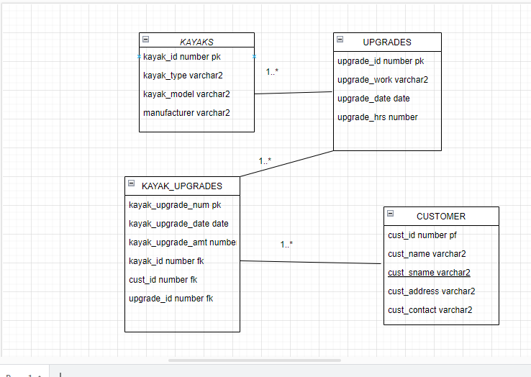

QUESTION 2

- Create KAYAKS table

CREATE TABLE KAYAKS (

KAYAK_ID NUMBER PRIMARY KEY,

KAYAK_TYPE VARCHAR2(50),

KAYAK_MODEL VARCHAR2(50),

MANUFACTURER VARCHAR2(50)

);

-- Create CUSTOMER table

CREATE TABLE CUSTOMER (

CUST_ID VARCHAR2(5) PRIMARY KEY,

CUST_FNAME VARCHAR2(50),

CUST_SNAME VARCHAR2(50),

CUST_ADDRESS VARCHAR2(100),

CUST_CONTACT VARCHAR2(15)

);

-- Create UPGRADES table

CREATE TABLE UPGRADES (

UPGRADE_ID NUMBER PRIMARY KEY,

UPGRADE_WORK VARCHAR2(50),

UPGRADE_DATE DATE,

UPGRADE_HRS NUMBER

);

-- Create KAYAK_UPGRADES table

CREATE TABLE KAYAK_UPGRADES (

KAYAK_UPGRADE_NUM NUMBER PRIMARY KEY,

KAYAK_UPGRADE_DATE DATE,

KAYAK_UPGRADE_AMT NUMBER,

KAYAK_ID NUMBER,

CUST_ID VARCHAR2(5),

UPGRADE_ID NUMBER,

FOREIGN KEY (KAYAK_ID) REFERENCES KAYAKS(KAYAK_ID),

FOREIGN KEY (CUST_ID) REFERENCES CUSTOMER(CUST_ID),

FOREIGN KEY (UPGRADE_ID) REFERENCES UPGRADES(UPGRADE_ID)

);

-- Populate KAYAK_UPGRADES table

insert into KAYAKS(kayak_id, kayak_type, kayak_model, manufacturer) values(12345, 'Single Seater', 'K100', 'FeelFree');

insert into KAYAKS(kayak_id, kayak_type, kayak_model, manufacturer) values(54321, 'Tandem Seater', 'J55', 'Roamer');

insert into KAYAKS(kayak_id, kayak_type, kayak_model, manufacturer) values(78945, 'Fishing Kayak','H9000', 'Wavesport');

insert into KAYAKS(kayak_id, kayak_type, kayak_model, manufacturer) values(98754, 'Hobie Kayak','A450', 'Gemini');

insert into KAYAKS(kayak_id, kayak_type, kayak_model, manufacturer) values(55311, 'Canadian Style','L920', 'Surge');

Select * from KAYAKS;

-- Populate CUSTOMER table

insert into CUSTOMER(cust_id, cust_fname, cust_sname, cust_address, cust_contact) values('C115', 'Jeff', 'Willis', '3 Main Road', '0821253659');

insert into CUSTOMER(cust_id, cust_fname, cust_sname, cust_address, cust_contact) values('C116', 'Andre', 'Watson', '13 Cape Road', '0769658547');

insert into CUSTOMER(cust_id, cust_fname, cust_sname, cust_address, cust_contact) values('C117', 'Wallis', 'Smith', '3 Mountain Road', '0863256574');

insert into CUSTOMER(cust_id, cust_fname, cust_sname, cust_address, cust_contact) values('C118', 'Alex', 'Hanson', '8 Circle Road', '0762356587');

insert into CUSTOMER(cust_id, cust_fname, cust_sname, cust_address, cust_contact) values('C119', 'Bob', 'Bitterhout', '15 Main Road', '0821235258');

insert into CUSTOMER(cust_id, cust_fname, cust_sname, cust_address, cust_contact) values('C120', 'Thando', 'Zolani', '88 Summer Road', '0847541254');

insert into CUSTOMER(cust_id, cust_fname, cust_sname, cust_address, cust_contact) values('C121', 'Philip', 'Jackson', '3 Long Road', '0745556658');

INSERT INTO CUSTOMER (CUST_ID, CUST_FNAME, CUST_SNAME, CUST_ADDRESS, CUST_CONTACT) VALUES ('C121', 'Philip', 'Jackson', '3 Long Road', '0745556658');

INSERT INTO CUSTOMER (CUST_ID, CUST_FNAME, CUST_SNAME, CUST_ADDRESS, CUST_CONTACT) VALUES ('C122', 'Sarah', 'Jones', '7 Sea Road', '0814745745');

Select * from CUSTOMER;

-- Populate UPGRADES table

insert into UPGRADES(upgrade_id, upgrade_work, upgrade_date, upgrade_hrs) values(1, 'Sonar Device', '15 July 2022', 5);

insert into UPGRADES(upgrade_id, upgrade_work, upgrade_date, upgrade_hrs) values(2, 'Padded Seats', '18 July 2022', 3);

insert into UPGRADES(upgrade_id, upgrade_work, upgrade_date, upgrade_hrs) values(3, 'GoPro Camera Mount','19 July 2022', 10);

Select * from UPGRADES;

-- Populate KAYAK_UPGRADES table

insert into KAYAK_UPGRADES(kayak_upgrade_num, kayak_upgrade_date, kayak_upgrade_amt, kayak_id,cust_id, upgrade_id) values(101, '27 July 2019', 75, 98754,'C121',3);

insert into KAYAK_UPGRADES(kayak_upgrade_num, kayak_upgrade_date, kayak_upgrade_amt, kayak_id,cust_id, upgrade_id) values(102, '20 July 2019', 30, 12345,'C120',2);

insert into KAYAK_UPGRADES(kayak_upgrade_num, kayak_upgrade_date, kayak_upgrade_amt, kayak_id,cust_id, upgrade_id) values(103, '23 July 2019', 75, 55311,'C119',1);

insert into KAYAK_UPGRADES(kayak_upgrade_num, kayak_upgrade_date, kayak_upgrade_amt, kayak_id,cust_id, upgrade_id) values(104, '17 July 2019', 50, 54321,'C117',1);

insert into KAYAK_UPGRADES(kayak_upgrade_num, kayak_upgrade_date, kayak_upgrade_amt, kayak_id,cust_id, upgrade_id) values(105, '19 July 2019', 30, 12345,'C122',2);

Select * from KAYAK_UPGRADES;

SELECT * FROM KAYAKS;

SELECT * FROM CUSTOMER;

SELECT * FROM UPGRADES;

SELECT * FROM KAYAK_UPGRADES;

QUESTION 3

-- Creating users

CREATE USER Tshepo IDENTIFIED BY tmphoabc2023;

CREATE USER Mya IDENTIFIED BY mrobertabc2023;

-- Granting privileges

GRANT CREATE SESSION TO Tshepo;

GRANT CREATE SESSION TO Mya;

GRANT SELECT ANY TABLE TO Tshepo;

GRANT INSERT ANY TABLE TO Mya;

QUESTION 4

--QUESTION 4

-- Create a SQL query to display the kayak id, customer id, upgrade hours and the kayak upgrade

--amount. In your query, include the total sales amount by multiplying the upgrade hours by the

--kayak upgrade amount

SELECT K.KAYAK_ID, CU.CUST_ID, U.UPGRADE_HRS UPGRADE_HRS,

('R ' || KAYAK_UPGRADE_AMT) KAYAK_UPGRADE_AMT,

('R ' || (U.UPGRADE_HRS * KU.KAYAK_UPGRADE_AMT)) TOTAL

FROM KAYAKS K, CUSTOMER CU, UPGRADES U, KAYAK_UPGRADES KU

WHERE K.KAYAK_ID = KU.KAYAK_ID

AND CU.CUST_ID = KU.CUST_ID

AND U.UPGRADE_ID = KU.UPGRADE_ID;

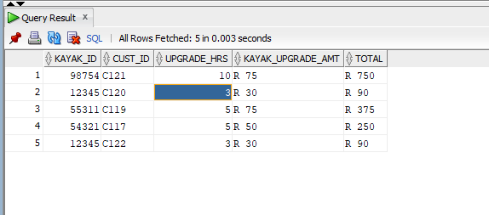

--QUESTION 5

--create a sql query to display the customer's full name,type of kayak, upgrade hours, upgrade work and kayak upgrade amount

SELECT

CONCAT(C.cust_fname, C.cust_sname) AS customer_name,

K.kayak_type,

UPG.upgrade_hrs,

UPG.upgrade_work,

KU.kayak_upgrade_amt

FROM

CUSTOMER C

JOIN

KAYAK_UPGRADES KU ON C.cust_id = KU.cust_id

JOIN

KAYAKS K ON KU.kayak_id = K.kayak_id

JOIN

UPGRADES UPG ON KU.upgrade_id = UPG.upgrade_id;

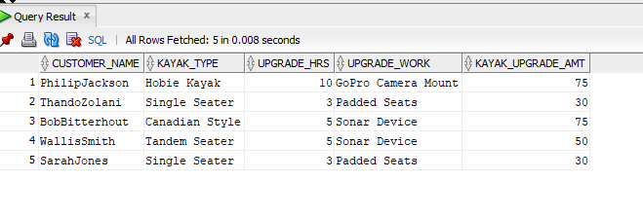

QUESTION 6

--QUESTION 6

--1. Create a PL/SQL query that will display the customer id, upgrade work done and the

--upgrade amount. In your query, only display the results where the upgrade amount is

--greater than R 50.

--2. Identify the type of cursor used and provide two reasons for its suitability in this query.

--Provide this information as a comment at the end of your code.

--3. Provide screenshot of query output.

SET SERVEROUTPUT ON

DECLARE

C_ID CUSTOMER.CUST_ID%TYPE;

U_WORK UPGRADES.UPGRADE_WORK%TYPE;

U_AMT KAYAK_UPGRADES.KAYAK_UPGRADE_AMT%TYPE;

CURSOR INFO IS

SELECT CU.CUST_ID, U.UPGRADE_WORK, KU.KAYAK_UPGRADE_AMT

FROM CUSTOMER CU, UPGRADES U, KAYAK_UPGRADES KU

WHERE CU.CUST_ID = KU.CUST_ID

AND U.UPGRADE_ID = KU.UPGRADE_ID

AND KU.KAYAK_UPGRADE_AMT > 50;

BEGIN

FOR REC IN INFO

LOOP

C_ID:=REC.CUST_ID;

U_WORK:=REC.UPGRADE_WORK;

U_AMT:= REC.KAYAK_UPGRADE_AMT;

DBMS_OUTPUT.PUT_LINE('CUSTOMER_ID: ' || C_ID || ', ' || CHR(10) ||

'UPGRADE WORK: ' || U_WORK || CHR(10) ||

'UPGRADE AMOUNT: R ' || U_AMT);

DBMS_OUTPUT.PUT_LINE('------------------------------------------------');

END LOOP;

END;

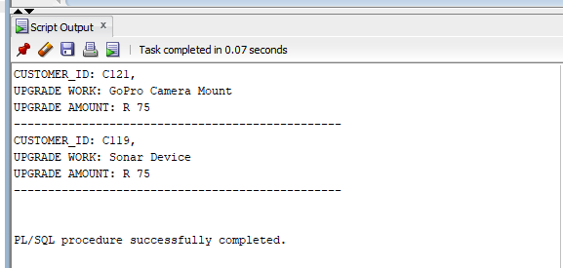

QUESTION 7

--QUESTION 7

--. Create a PL/SQL query that will display the customer name, type of kayak, upgrade work

--and the upgrade date. In your query display the upgrade amount and a discount amount

--(10%), that will be subtracted off customer 'C121' final bill only.

--2. Provide screenshot of query output.

SET SERVEROUTPUT ON

DECLARE

C_NAME CUSTOMER.CUST_SNAME%TYPE;

K_TYPE KAYAKS.KAYAK_TYPE%TYPE;

U_WORK UPGRADES.UPGRADE_WORK%TYPE;

KU_DATE KAYAK_UPGRADES.KAYAK_UPGRADE_DATE%TYPE;

U_AMT KAYAK_UPGRADES.KAYAK_UPGRADE_AMT%TYPE;

DISCOUNT KAYAK_UPGRADES.KAYAK_UPGRADE_AMT%TYPE;

CURSOR INFO IS

SELECT (C.CUST_FNAME || ' ' || C.CUST_SNAME) CUSTOMER, K.KAYAK_TYPE, U.UPGRADE_WORK,

KU.KAYAK_UPGRADE_DATE, KU.KAYAK_UPGRADE_AMT, (KU.KAYAK_UPGRADE_AMT * 0.10)

DISCOUNT_AMOUNT

FROM CUSTOMER C, KAYAKS K, UPGRADES U, KAYAK_UPGRADES KU

WHERE C.CUST_ID = KU.CUST_ID

AND K.KAYAK_ID = KU.KAYAK_ID

AND U.UPGRADE_ID = KU.UPGRADE_ID

AND C.CUST_ID = 'C121';

BEGIN

FOR REC IN INFO

LOOP

C_NAME:=REC.CUSTOMER;

K_TYPE:=REC.KAYAK_TYPE;

U_WORK:=REC.UPGRADE_WORK;

KU_DATE:=REC.KAYAK_UPGRADE_DATE;

U_AMT:=REC.KAYAK_UPGRADE_AMT;

DISCOUNT:=REC.DISCOUNT_AMOUNT;

DBMS_OUTPUT.PUT_LINE('CUSTOMER: ' || C_NAME || CHR(10) ||

'KAYAK TYPE: ' || K_TYPE || CHR(10) ||

'UPGRADE WORK: ' || U_WORK || CHR(10) ||

'UPGRADE DATE: ' || KU_DATE || CHR(10) ||

'UPGRADE AMT: R ' || U_AMT || CHR(10) ||

'DISCOUNT AMT: R ' || DISCOUNT || CHR(10));

DBMS_OUTPUT.PUT_LINE('----------------------------------');

END LOOP;

END;

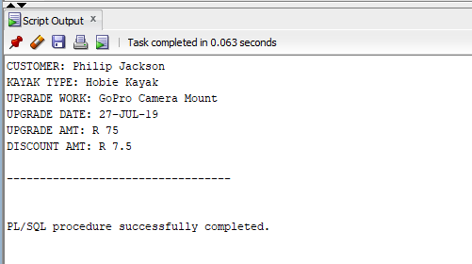

QUESTION 8

--QUESTION 8

--1. Create a view called vwCustomerUpgrades that will display the combined customer name,

--kayak type, upgrade work and the customer contact number. In your query, only display

--the customers whose address contains the word 'Summer'. 2. Briefly explain the concept of vertical and horizontal partitioning based on this scenario .

--Provide this information as a comment at the end of your code.

--3. Provide screenshot of query output.

CREATE OR REPLACE VIEW VWCUSTOMERUPGRADES

AS

SELECT C.CUST_FNAME || ' , ' || C.CUST_SNAME CUSTOMER, K.KAYAK_TYPE, U.UPGRADE_WORK,

C.CUST_CONTACT

FROM CUSTOMER C, KAYAKS K, UPGRADES U, KAYAK_UPGRADES KU

WHERE C.CUST_ID = KU.CUST_ID

AND K.KAYAK_ID = KU.KAYAK_ID

AND U.UPGRADE_ID = KU.UPGRADE_ID

AND C.CUST_ADDRESS LIKE '%Summer%';

SELECT * FROM VWCUSTOMERUPGRADES;

---4--

CREATE VIEW vwCustomerRepairs AS

SELECT CONCAT(cust.cust_sname, ', ', cust.cust_fname) AS CUSTOMER,

kay.kayak_type AS CLUB_TYPE,

ku.upgrade_work AS REPAIR_WORK,

cust.cust_contact AS CONTACT

FROM CUSTOMER cust

JOIN KAYAK_UPGRADES ku ON cust.cust_id = ku.cust_id

JOIN KAYAKS kay ON ku.kayak_id = kay.kayak_id

WHERE cust.cust_address LIKE '%Summer%';

